create database s s s ;

ERROR 1064 (42000): You have an error in your SQL syntax; **check the manual** that corresponds to your MySQL server version for the right syntax to use **near 's s'** **at line 1**

**Charset latin1 -- 不支持中文**

**utf8 推荐使用**

create database s1 charset=utf8;

create database s1;

ERROR 1007 (HY000): Can't create database 's1'; **database exists**

create database if not exists s1;

Query OK, 1 row affected, 1 warning (0.01 sec)

show warnings;

+-------+------+---------------------------------------------+

| Level | Code | Message |

+-------+------+---------------------------------------------+

| Note | 1007 | Can't create database 's1'; database exists |

+-------+------+---------------------------------------------+

1 row in set (0.00 sec)

show create database s1;

+----------+-------------------------------------------------------------+

| Database | Create Database |

+----------+-------------------------------------------------------------+

| s1 | CREATE DATABASE `s1` /*!40100 DEFAULT CHARACTER SET utf8 */ |

+----------+-------------------------------------------------------------+

1 row in set (0.00 sec)

show create database sssss;

+----------+----------------------------------------------------------------------------------------------+

| Database | Create Database |

+----------+----------------------------------------------------------------------------------------------+

| sssss | CREATE DATABASE `sssss` /*!40100 DEFAULT CHARACTER SET utf8mb4 COLLATE utf8mb4_0900_ai_ci */ |

+----------+----------------------------------------------------------------------------------------------+

1 row in set (0.00 sec)

use sssss;

Database changed

删除数据库

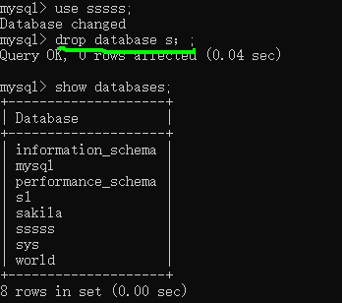

> drop database s；;

ERROR 1008 (HY000): Can't drop database 's；'; database doesn't exist

drop database **if exists** s；;

Query OK, 0 rows affected, 1 warning (0.00 sec)

Note (Code 1008): Can't drop database 's；'; database doesn't exist